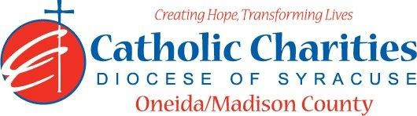
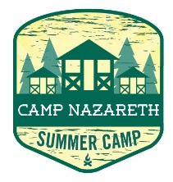
Department: Camp Nazareth
Job Title: Arts & Crafts Counselor
Date: 03/5/2025
Reports to: Assistant Camp Director
Qualifications:
Education/Experience
- Must be at least 18 years of age with previous experience in camping and supervision of children.
- Experience and training in special activity areas, such as, arts and crafts, and/or character education.
- Ability to work well with others in a team setting.
- Ability to always act as a positive role model.
- Ability to always maintain professional boundaries with campers and staff.
- Employment is contingent upon approval from NYS Health Department Which includes notification from NYSDSS Central Register of Abuse and Maltreatment that the director has not been subject of an investigation report and submission of the form Prospective Children’s Camp Director Certified Statement Relative to the Conviction of a crime or Existence of a pending criminal action, free of communicable diseases, and any other regulatory governmental entities requitements.
Major Function:
Administrative
- Responsible for immediate supervision of campers, provide leadership and guidance to all campers.
- Ensure maximum safety for all campers.
- Interpret camp safety and health regulations for campers.
- Supervise arts and crafts room/area and housekeeping of arts & crafts room/area
- In conjunction with Camp leadership team devise an Arts & Crafts agenda and projects for camp
- Coordinate and lead Arts & Crafts activities.
- Maintain daily logbook.
- Organize and devise a system for keeping Arts & Crafts supplies.
- Meet with camp leaders on daily basis.
- If needed, Lead special activity groups.
- If needed, escort campers to and from all daily activities.
- Provide supervision during Arts & Crafts programs.
- If needed, assist Lead Counselor in activity planning and lead activities.
- If needed, assist with Sunday registration.
- If needed, complete cabin/bunker clean-up and preparation for Sunday arrivals before departure on Friday evenings.
- Inform Assistant Camp Director of any situations jeopardizing the health/safety of staff/campers.
- Uphold Camp Nazareth’s philosophy and always enforce proper policy and procedures.
Catholic Charities Agency and Community
- Attending all internal staff meetings and program related meetings, as necessary.
- Participate in in-service training sessions, workshops, conferences and/or continuing education programs within Catholic Charites or the larger community, as necessary.
- Participate in other duties, programs and activities within the Department as directed.

